Startup Founder Burnout & Failure Risk Analysis (2026)
Project Report
Prepared by: Makarand A Bhambure
Date: September 2026
Dataset: startup_founder_burnout_2026.csv (50,000 founders)

1. Executive Summary
This project analyses a dataset of 50,000 startup founders to understand how burnout, co-founder conflict, financial runway and the economic climate relate to the risk that a startup shuts down. The raw data was cleaned using Python and SQL, three risk columns were created (Shutdown_Probability, Shutdown_Risk and Startup_Failure_Flag), and the data was explored, modelled and turned into an interactive risk calculator.
Main results: 23.7% of startups are flagged as failures; the failure rate climbs from 7.9% for founders with low burnout to 69.0% for those with severe burnout; and a logistic regression model predicts the failure flag with a ROC-AUC of about 0.95 on unseen data.

2. Objectives
- Clean and validate the founder dataset so it is reliable for analysis.
- Create risk indicators that summarise how likely a startup is to shut down.
- Identify the founder, team and business factors most linked to failure.
- Build and evaluate a model that predicts startup failure.
- Deliver an easy-to-use risk calculator for scenario testing.

3. Dataset Description
The final cleaned file contains 50,000 rows and 29 columns, with no missing values and no duplicate rows. The columns fall into the groups below.
Group | Columns
Founder & company | Founder_Type, Founder_Age, Founder_Experience_Years, Industry, Funding_Stage, Work_Mode, Team_Size, Startup_Age_Months, Economic_Climate
Lifestyle & stress | Weekly_Work_Hours, Sleep_Hours, Exercise_Days_Per_Week, Vacation_Days_Taken, Work_Life_Balance_Score, Stress_Score, Decision_Fatigue_Score, Burnout_Score, Burnout_Level, Founder_Burnout_Flag, Seeks_Mental_Health_Support
Pressure & team | Investor_Pressure_Score, Cofounder_Conflict_Score, Employee_Turnover_Percent
Business health | Monthly_Revenue_Growth_Percent, Runway_Months_Remaining, Product_Market_Fit_Score
Created by the author | Shutdown_Probability, Shutdown_Risk, Startup_Failure_Flag

4. Data Cleaning and Preparation
The original data contained missing values, duplicate records and values in wrong formats. These were corrected in VS Code with Python and SQL. The analysis notebook repeats the same steps so the work can be reproduced from the raw file.
- Standardised column names and text values (trimmed spaces, consistent capitalisation, uniform Yes/No labels).
- Converted numeric columns stored as text (for example values with %, commas or currency symbols) to proper numbers.
- Set impossible values (for example sleep above 24 hours or scores outside 0-10) to missing so they could be treated like other missing values.
- Removed exact duplicate rows, keeping the first occurrence; SQL (SQLite) was used for de-duplication and sanity filtering.
- Filled missing numeric values with the median and missing categories with the most frequent value.
- Reviewed outliers with the IQR rule. Team_Size is strongly right-skewed, so it was flagged and log-transformed instead of deleted, because very large startups do exist.
- Ran validation checks: no missing values, no duplicates, all values inside valid ranges, binary flags only contain 0/1.
One logical issue was reported but not removed: 46 rows (0.09%) where age minus years of experience is under 16.

5. Feature Engineering
Column | Rule | Meaning
Shutdown_Probability | Score between 0 and 1 | Estimated chance the startup shuts down
Shutdown_Risk | Low < 0.35; Medium 0.35-0.65; High > 0.65 | Risk category
Startup_Failure_Flag | 1 if risk is High, else 0 | Binary failure target
Burnout_Level | Low < 3.5; Moderate 3.5-6.5; Severe > 6.5 | Category from Burnout_Score

Extra features were added for analysis and modelling: Log_Team_Size, Experience_Ratio, Sleep_Deficit, Overwork_Flag, Stress_Load_Index, Recovery_Index, Burn_Rate_Pressure and Startup_Stage_Group.

6. Exploratory Data Analysis
Overall, 23.7% of the startups have Startup_Failure_Flag = 1. Burnout and the economic climate show the clearest differences.
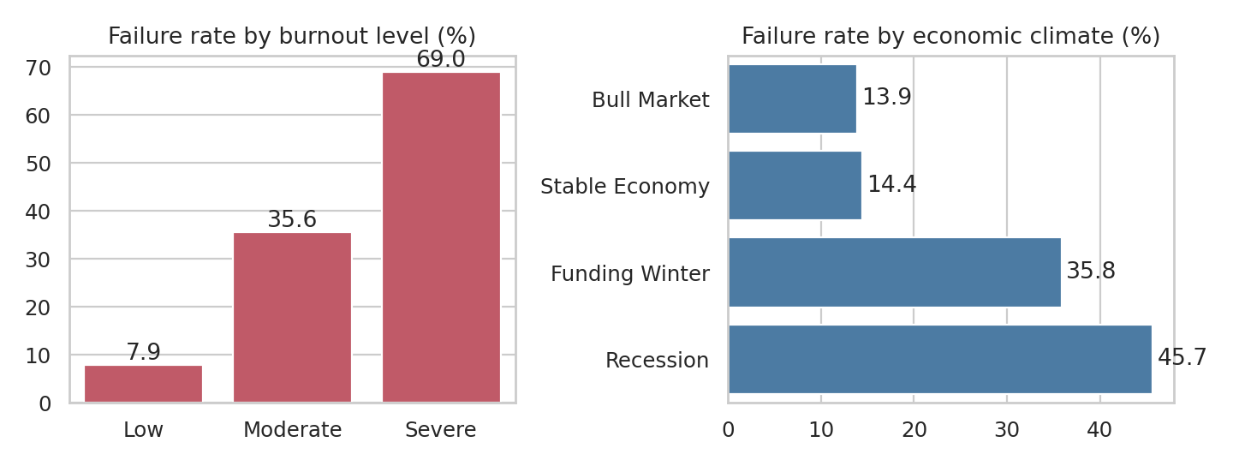
Figure 1: Failure rate by burnout level and by economic climate
- Failure rate by burnout level: Low 7.9%, Moderate 35.6%, Severe 69.0%.
- Failure rate by climate: Recession 45.7%, Funding Winter 35.8%, Stable Economy 14.4%, Bull Market 13.9%.
- Failure rate by funding stage: Bootstrapped 30.1% (highest), Series C 15.5% (lowest).
- Founder types differ widely: Growth Obsessed Founder 39.1% versus Calm Operator 5.1%.
- Work mode makes almost no difference (Remote 23.9%, Hybrid 23.7%, Office 23.4%).
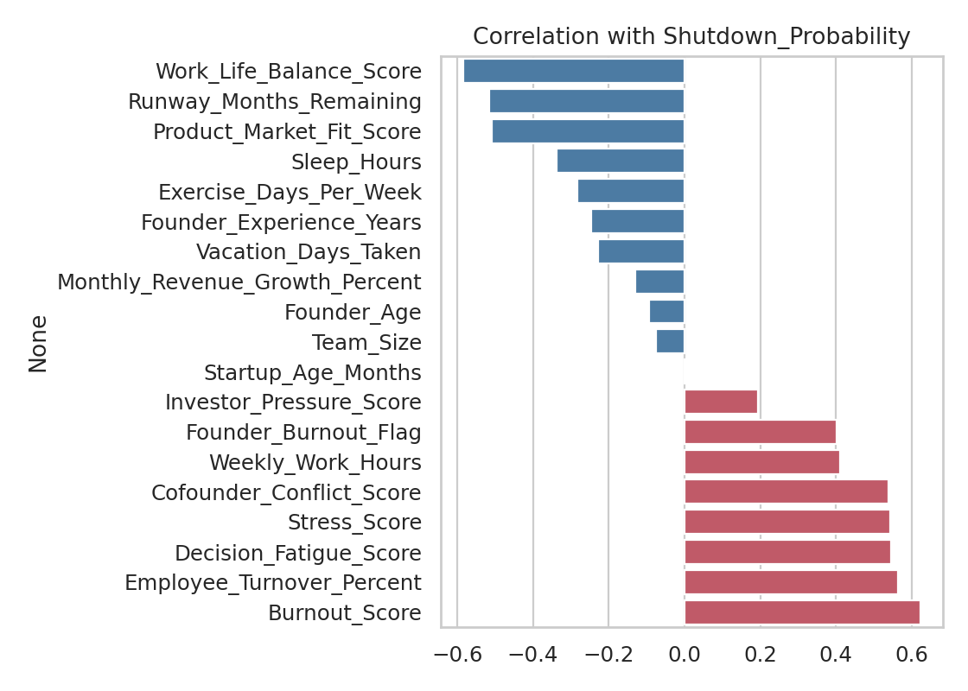
Figure 2: Correlation of each numeric variable with Shutdown_Probability
Burnout_Score, Employee_Turnover_Percent, Decision_Fatigue_Score, Stress_Score and Cofounder_Conflict_Score are positively related to shutdown probability. Work_Life_Balance_Score, Runway_Months_Remaining and Product_Market_Fit_Score are negatively related. Statistical tests confirm the differences: a Mann-Whitney test on Burnout_Score (failed vs survived) and a chi-square test of Funding_Stage vs failure both give p-values far below 0.001.

7. Startup Failure Risk Calculator
A standalone HTML application (startup_failure_risk_calculator.html) lets a user adjust five inputs and see the predicted shutdown probability instantly: founder burnout score, co-founder conflict score, runway months remaining, investor pressure and economic climate.
The calculator uses a logistic model fitted on the 50,000-founder dataset:
Shutdown probability = 1 / (1 + e^-z), where z = -1.4227 + 0.2688 x Burnout + 0.2294 x Conflict - 0.1038 x Runway - 0.0033 x Investor + climate effect
Climate effects: Bull Market -0.02, Stable Economy 0 (baseline), Funding Winter +0.63, Recession +0.92. The model explains 72% of the variation in Shutdown_Probability (R-squared = 0.72) and ranks failing startups correctly with an AUC of 0.93 for Startup_Failure_Flag.
Features: preset founder archetypes, a side-by-side comparison of up to four saved scenarios, a runway sensitivity curve, a radar chart against the dataset average, and an automatic what-if recommendation that tests the effect of more runway, lower burnout or lower conflict. Risk colours follow the same cut-offs as the dataset (Low < 35%, Medium 35-65%, High > 65%).
Investor pressure has almost no independent effect in the model (coefficient close to zero) once burnout, conflict, runway and climate are known.

9. Conclusions and Recommendations

- Burnout is the strongest human factor: severe burnout is associated with roughly nine times the failure rate of low burnout.
- Co-founder conflict and high employee turnover are the next strongest warning signs.
- A longer runway and strong product-market fit reduce risk; in a Recession or Funding Winter founders should build extra runway.
- Founders should protect sleep, rest and work-life balance; these are linked with lower burnout and lower shutdown probability.
- Investors and advisers can use burnout, conflict and runway as early-warning indicators.

10. Limitations
- The results show association, not causation. For example, founders who seek mental-health support have a higher failure rate (30.6% vs 21.2%), which most likely reflects that struggling founders seek help.
- Shutdown_Probability is a constructed score, so the model learns that score rather than real-world shutdown outcomes.
- The calculator uses five inputs only and is an educational simulator, not financial advice.
- The cleaning code was run on the final cleaned file; applying it to new raw data should be followed by a manual review.

11. How to Reproduce
- Install dependencies: pip install -r requirements.txt
- Place startup_founder_burnout_2026.csv next to the notebook.
- Open startup_founder_burnout_analysis.ipynb in Jupyter or VS Code and choose Run All.
- Open startup_failure_risk_calculator.html in a web browser to use the calculator.

12. Technologies Used
Python, pandas, NumPy, SQLite, Matplotlib, Seaborn, SciPy, scikit-learn, Jupyter Notebook, HTML, Tailwind CSS and Chart.js.

